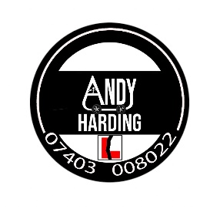 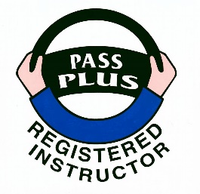

1. Thank you for your enquiry about lessons. Under normal conditions, availability of lessons would become more frequent due to a large amount of tests conducted over a monthly period of time. However, the current backlog of tests waiting to be rebooked may cause disruption to lesson plans.
2. This document is purely for providing prices and conditions of services, and is not a confirmation of booking. Confirmation of booking is briefly explained in paragraph 9.
3. In accordance with the Approved Driving Instructor (ADI) Code of Practice, I would like to confirm the following:
   1. The fee is £34.00 per hour (Mon to Fri) £38.00 per hour (Sat and Sun) for automatic lessons and each lesson is two hours long.
   2. The test period is set and charged at either 2 or 3 hours depending on the location of the test centre. The DVSA test fee is separate from this fee (paragraph 3g).
   3. The current economic and cost of living crisis means that there are no block booking discounts available.
   4. Training intensity can vary from one to three lessons a week. This is depedant if the student is able to take on an increasing training load in a short time.
   5. With the changes to the DVSA’s Cancellation and retest procedures, this school will not conduct intensive driver training.
   6. All lessons must be paid for in advance, either by card, or bank transfer. Paying at the end of the lesson is no longer an accepted practice. Non-attendance of lessons that is due for payment will result in an invoice being sent to the student’s address (para 3h).
   7. The practical driving test booking fee is a separate charge directly payable to the DVSA (currently set at £62.00). This can be arranged on your behalf with the test fee payable directly to the Driving school. Payment for the test must be made before the test is booked.
   8. Cancellation of lesson policy. Cancellation of lessons can not only have a detrimental effect in continuation of learning, but also the instructor’s earnings. The following policy is in place.
4. Lessons will strictly be charged unless at least 48 hour notice is given on late cancellation and/or failing to attend. If the lesson is yet to be paid for, an invoice will be sent for payment. The invoice will have a due date for payment. If payment is not met, a further invoice will be sent with an additional administration charge of £35 with a 14 day due date. If the payment is not made, Legal proceedings will be processed for recovery of monies owed (plus costs) via the small claims court.
5. Excessive cancellation of lessons will result the Driving School in removing the Student from the Instructor’s diary.
   1. If a refund is requested from yourself, all unspent funds will be transferred back ideally to the account from which it the payment was originated from (the final refund will take in consideration of the provisions of paragraphs 3c, 3e, 3f and 3g).
6. Before the first lesson, please do the following:
   1. You will need to generate a code in order to check licence details online.
   2. The information you will need is the driving licence number, national insurance number and postcode.
   3. Go to <https://www.gov.uk/view-driving-licence> where you will be asked to enter the details as described in paragraph 4b.
   4. You will see a link that says “share licence information”. Click on that link and this creates a code.
   5. Send back the code together with the driving licence number. The code is case sensitive, can only be used once, and is only valid for 21 days.

Getting this done early and before the first lesson saves a lot of time as we can spend more time concentrating on the lessons.

1. For the first lesson:
   1. Please ensure the licence is brought along for a visual check. The licence must be present for each lesson.
   2. If there is a need to wear spectacles or contact lens, please ensure they are also brought along, as there will be a quick eyesight check before getting in the car.
   3. Please ensure suitable footwear is worn (e.g. no sandals, flip flops, sliders or high heels).
2. During the lesson:
   1. It is a learning environment for not only the Student, but also the Instructor. The Instructor will give feedback at appropriate points of the lesson. The Instructor also relies on the Student to give feedback on what is being taught in order to allow the Instructor to change coaching styles or change the learning tempo. It is always encouraged to maintain a happy atmosphere during the lessons.
3. The school reserves the right to refuse use of the car for the Practical Driving Test if the Instructor believes that it would be unsafe for the test candidate to drive on it.
4. The school will always try to use suitable areas for learning. However, the school also reserves the right to stop and terminate the lesson if public safety is at risk at the hands of the student.
5. If you agree with the prices and terms, and you would like to book your first driving lesson with us, please do the following:
   1. Respond to this document by completing your details requested on page 4.
   2. A deposit of £34.00 is to be made to secure the first booking. This deposit is returnable if cancellation is made more than 48 hours before the start of the first lesson.
6. If you have any questions or queries, please do not hesitate to get back in touch.

Regards

Andy Harding Driving School

31 Stakeford Cresent

Stakeford

Choppington

NE62 5JT

[Tel: 07403](Tel:07403) 008022

Email: [enquiries@andyhardingdrivingschool.com](mailto:enquiries@andyhardingdrivingschool.com)

<https://www.andyhardingdrivingschool.com>

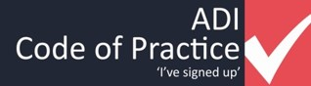

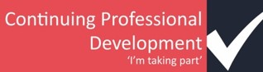

GDPR compliant – ZA354403

Items in bold must be entered.

**Name:**

**Address:**

**Home phone:**

**Mobile:**

**Email:**

**Driving Licence No:**

**Type of licence:**

**DVLA Code:**

Applied Theory Test Y/N:

Theory Test Date:

Passed Theory Test Y/N:

Test Expiry Date:

Target Practical Test date:

Practical Test Date & Time:

Test Centre for Practical Test:

**Availability of lessons (Days/Times):**

|  |  |  |  |  |
| --- | --- | --- | --- | --- |
| **Mon** | **Tue** | **Wed** | **Thu** | **Fri** |

**Method of payment (Cash/Card/Bank Transfer):**

Pick up Location if not home:

Any additional Information/Notes: